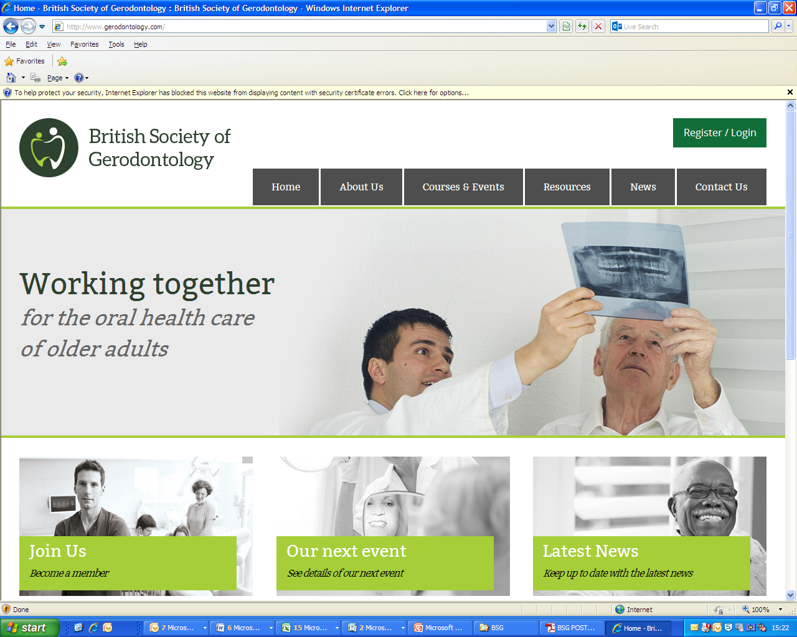

**BSG Research Award - guidance and regulations**

**Overview**

*CLOSING DATE*for receipt of applications: 31/March/25

Applicants informed of the outcome: 30/April/25

Recipient conducts research: 1 /May/25 – 20/April/2026

Recipients will present research at summer BSG meeting: June 2026

The British Society of Gerodontology is delighted to offer a research prize to support a project related to Gerodontology. The BSG Research Award seeks to support early career researchers in the field of Gerodontology to undertake high-quality research that benefits patients cared for in Special Care Dentistry services.

There will be a maximum of one award within a 12-month period (calendar year) of up to £5000. Applicants will be informed of the outcome of their application within 3 months of submission. Unsuccessful applicants can resubmit an application but not within 12 months of the original submission.

**Eligibility**

We do not anticipate this award being appropriate for experienced researchers or those already holding a PhD or higher research degree. The applicant does not have to be a dentist and applications from Dental Care Professionals, related healthcare professionals or those working in related disciplines will be considered. The award should lead to the development of an early career researcher’s academic career and application for further substantial research funding such as from the National Institute for Health Research or one of the UK’s Research Councils.

**To be eligible for the award you must:**

• Be a current member of BSG

• Not already hold an MPhil, MD, or PhD

• Have no existing or alternative funding for the proposed project

• Ensure they have established, academic supervision from a university-associated staff member who can support the research project.

**Project Requirements**

The project should:

• Include novel research that benefits older patients (over 65 years) who would be cared for in Community Dental Services and/or Special Care Dentistry services

• Receive appropriate ethical approval as per the UK Policy Framework for Health and Social Care Research unless this is clearly not required for your chosen project (this must be justified in your application)

• Be feasible and achievable within the timescale presented

• Be cost-effective to undertake

**Completing your application**

Your project abstract (Section 2 of application form) should be presented in simplified (lay) language where possible. This 300-word summary will be used to summarise applications to the BSG Committee. Please present this abstract in manner like an academic paper abstract (ie Background, Aim and Objectives, Methods, Data Analysis, Potential Benefit to Patients)

Your comprehensive summary (Section 4 of application form) should provide more granular detail about your planned approach to the project. Please explain your overall project plan in up to 3000 words. You can divide this section as you wish, but please describe:

• Any existing research in this area and why your research is required

• Your proposed methods and the justification for this

• The specific aim, research question and objectives of your project

• How you plan to involve patients and members of the public (not simply as participants). Please see NIHR guidance for Patient and Public Involvement in research for more information <https://www.nihr.ac.uk/documents/ppi-patient-and-public-involvement-resources-for-applicants-to-nihr-research-programmes/23437>

• Overview of your data analysis plan

• How you plan to disseminate your findings